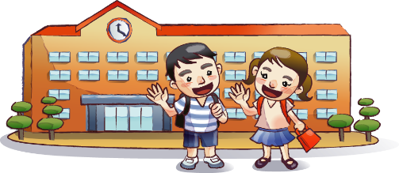

**After School Schedule**

**Hang Up Coat**

**Empty Backpack**

Look at my assignments for the day

Make sure I have everything I need for homework

Give Mom or Dad any parent papers

Clean out lunch box

**Have a Snack**

Wash my hands first

Tell Mom and Dad about my day

**Relax and unwind. I can…**

Read a book

Go outside and play

Play a game

Invite a friend over (ask Mom or Dad first)

**Do My Homework**

Double check my work

Pack my backpack for tomorrow

**Dinner and Chores**

Help set/clear the table

Take out the trash

Other:

**TV or Computer Time**

Stick to the time limits