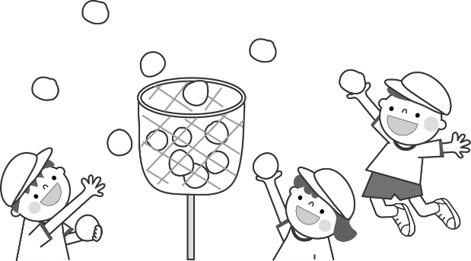

***After School Schedule***

|  |  |  |  |  |  |
| --- | --- | --- | --- | --- | --- |
| **Time/Period** | **Monday** | **Tuesday** | **Wednesday** | **Thursday** | **Friday** |
| 00 – 00 PM | Arrival  Free Play | Arrival  Free Play | Arrival  Free Play | Arrival  Free Play | Arrival  Free Play |
| 00 – 00 PM | Snack Time | Snack Time | Snack Time | Snack Time | Snack Time |
| 00 – 00 PM | Sports & Games  Arts & Crafts | Sports & Games  Arts & Crafts | Sports & Games  Arts & Crafts | Sports & Games  Arts & Crafts | Sports & Games  Arts & Crafts |
| 00 – 00 PM | Homework  Reading / Club | Homework  Reading / Club | Homework  Reading / Club | Homework  Reading / Club | Homework  Reading / Club |
| 00 – 00 PM | Gym Time  Game Room | Gym Time  Game Room | Gym Time  Game Room | Gym Time  Game Room | Gym Time  Game Room |
| 00 – 00 PM | Pick Up | Pick Up | Pick Up | Pick Up | Pick Up |
| 00 – 00 PM | Sleep Time | Sleep Time | Sleep Time | Sleep Time | Sleep Time |

https://www.schedulesbox.com/